Attention King Soopers (Friends of Rocky Mountain Robotics) Gift Card Holders:
PLEASE NOTE that King Soopers has changed the way they handle their Rewards program. You will still be able to use your Rocky Mountain Robotics-issued King Soopers Gift Card until your balance is zero, but afterwards you will not be able to reload that gift card.
The new Rewards program uses only your regular King Soopers Shoppers Card. Once you link that card to our program (see instructions below), a portion of all of your King Soopers purchases, regardless of payment method, will benefit the Friends of Rocky Mountain Robotics.
If you, like me, have gotten used to the convenience of using a gift card for your purchases, note that you can still purchase normal King Soopers gift cards at the store.
We would love it if everyone would please follow the steps below to link your King Soopers shoppers card to our team account to continue to help support the team.
INSTRUCTIONS (screenshots on subsequent pages):
- Log on to KingSoopers.com
- In the upper right-hand corner, click Sign In.
- If you have already created an account, just sign in. If not, click Create Account and create your account now.
- After logging in, click on your name in the upper right-hand corner and select My Account from the drop-down list.
- Click Community Rewards on the left-hand side of the page.
- Under Find an Organization, enter: JH760 and click Search.
- Click Enroll to link your account to Friends of Rocky Mountain Robotics.
- That’s it. You should see a green checkmark and the words "You have successfully enrolled in Community Rewards".
Thank you for your continued support of Rocky Mountain Robotics!

You need to log in to kingsoopers.com with the account that has your SuperCard associated with it.

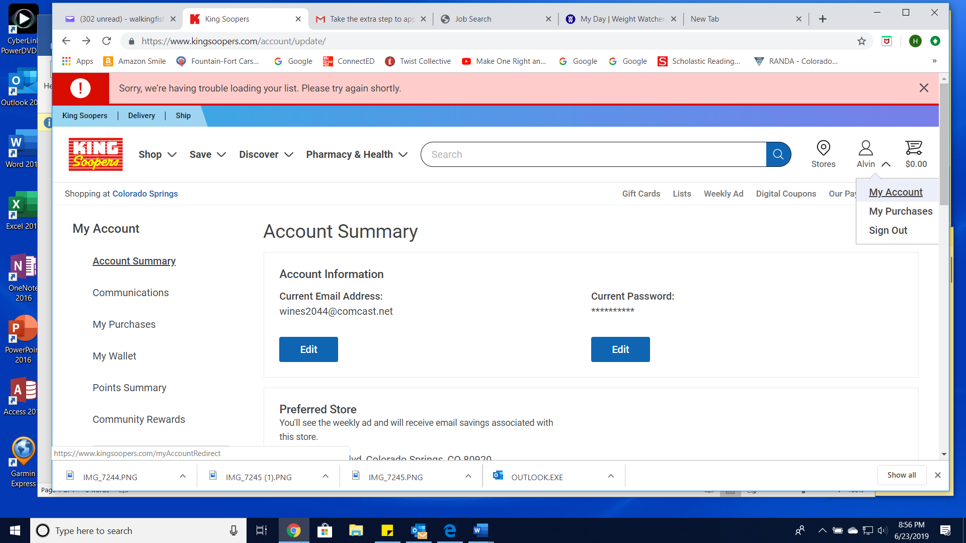

Then click on Community Rewards on the left hand side.
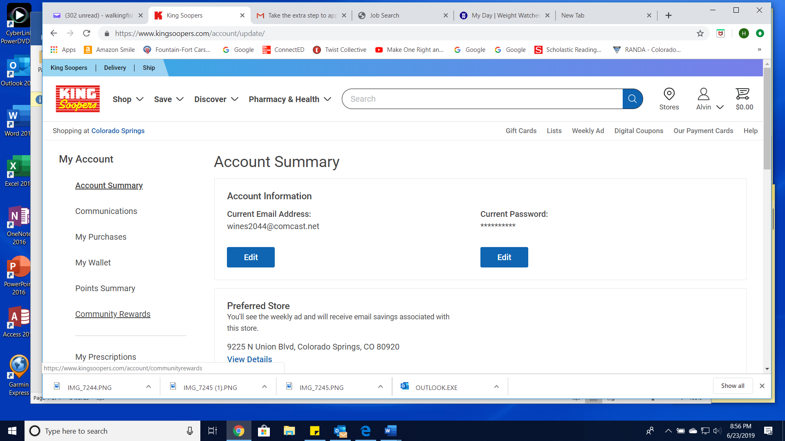
In the Find an Organization textbox, enter: JH760 and click Search

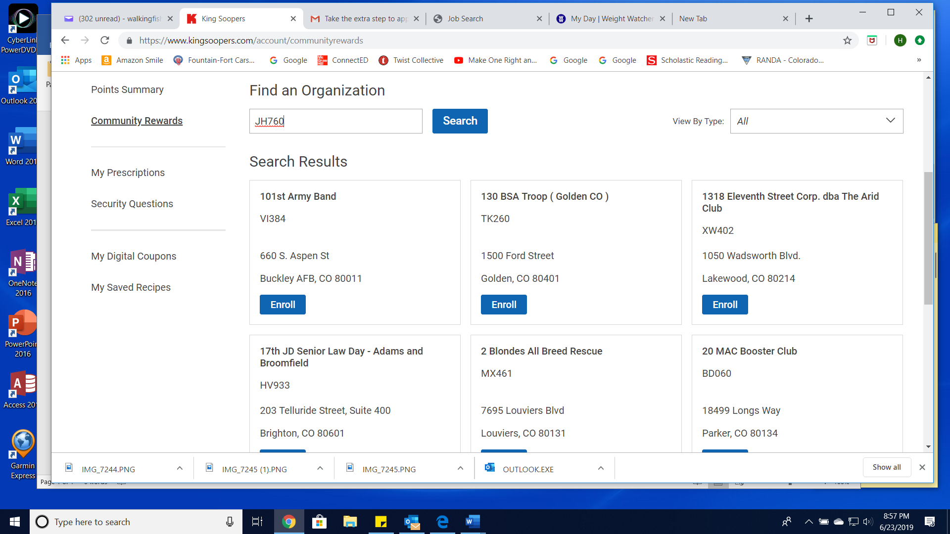

Click on Enroll under the Friends of Rocky Mountain Robotics
