Rocky Mountain Robotics

Team 662

Safety Plan
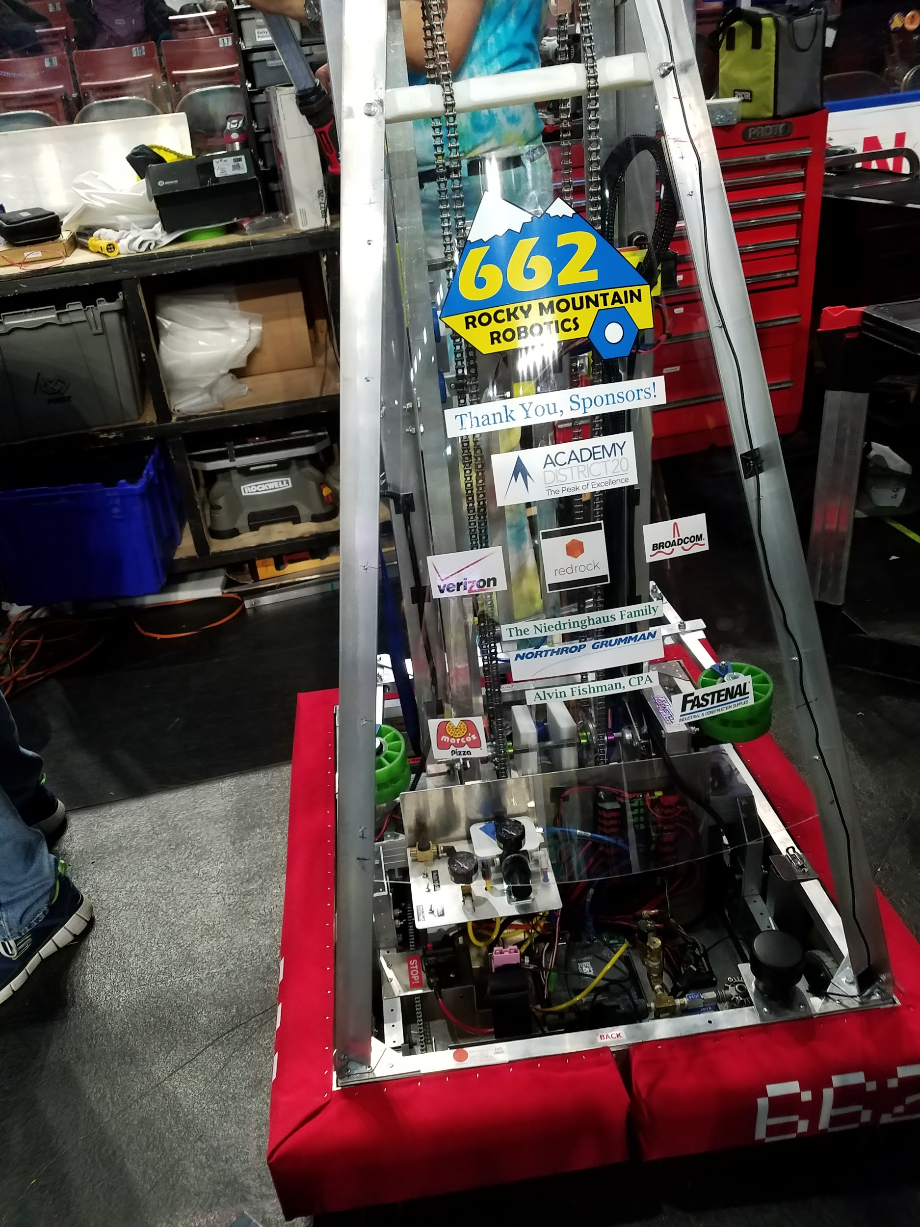

We don’t build robots.
We build people who build robots.
2018-2019
RMR Safety Policy

The following safety policy is provided as a guide to assist students and mentors in complying with the requirements of basic safety procedures in a working environment, as well as to provide other helpful information. The students, mentors and/or any persons who want to work in the build space or operate in the pit should review the standards and requirements for different situations which are applicable to their individual situation. The Vice President, per their department, should also review this material in case of lack of quality.

2018-2019
RMR Safety Policy
Table of contents

I. Objective

II. Policy

III. Applicability

IV. Implementation

V. Administration

VI. Reporting Injuries

VII. Basic Safety Rules

VIII. Enforcement of Safety Policy

IX. Outreach

X. Attachments

A. Build Space Safety Checklist

B. Robot Operation Checklist

C. Pit Area Checklist

D. Safety Equipment Checklist

2018-2019
RMR Safety Policy

I. OBJECTIVE
The Safety Policy of Team 662 is to maintain a safe and injury free environment fit for all ages to learn about robotics. Our desire to teach our generation of the engineering world through robotics must sustain a solid form of security for all students. By complying with basic safety guidelines of the various equipment we can achieve an optimal working environment.

II. POLICY
It is Team 662’s policy that accident prevention be a prime concern of all participants. This includes the safety and wellbeing of our students, mentors and leadership, as well as the prevention of wasteful, inefficient operations, and damage to equipment.

III. APPLICABILITY
This Safety Policy applies to all members of Team 662 regardless of position or age within the team. The Safety Rules also applies to all persons who are in the build space or the pit.

IV. IMPLEMENTATION
This Safety Policy supports maximum student involvement. We give effective training done by trained mentors to all students who wish to use a power tool.

V. ADMINISTRATION
The Safety Policy will be carried out according to guidelines stated in the safety policy. Specific instructions and assistance will be provided by the current Safety Captain as requested. The Safety Captain will be responsible for meeting all the requirements of the Safety Policy, and for maintaining an effective accident prevention effort within his or her area of responsibility.

VI. REPORTING OF INJURIES
All students will be held accountable for informing the safety captain or representative immediately after an injury occurs. (Notice must be made at or near the time of the injury and on the same hour of the injury.)

VII. BASIC SAFETY RULES

- Basic knowledge of power tools will be required to operate them. If one does not know how to operate ask a mentor or VP and they will help you.

- All injuries, must be reported to the safety captain immediately.

- Safety glasses will be worn as the minimum-required eye protection at all times in the build space. Additional ear protection may be required depending on the tool in use.

- Clothing must provide adequate protection to the body. Long pants will be worn at all times. No shorts will be worn on projects. Adequate working shoes, such as tennis shoes, must be worn in build space. No open toed shoes or sandals.

- Drinks and beverages will not be allowed in certain areas of the build space due to the danger of property damage and risk to personal injury.

- Work areas must be kept clean and organized even when working on a project. A cluttered workplace promotes discrepancy in safety in the build space.

- All tools, must be in good working condition. Defective tools must not be used. Examples of defective tools include chisels with mushroomed heads, hammers with loose or split handles, guards missing on saws or grinders, etc.

- “Horseplay" in the build space is strictly prohibited. Running on the build space is allowed only in extreme emergencies.

- Fire extinguishing equipment shall be kept nearby if ever needed in an emergency and will also be replaced if need be.

- Report all unsafe conditions and near accidents to the current safety captain so corrective action can be taken.

- When placed in a dire situation where the need of immediate medical attention is required, call 911 immediately then notify safety captain and present mentors.

VIII. ENFORCEMENT OF SAFETY POLICY

Severe safety violations will be notified to the mentors and any severe violation of safety rules can result in removal from the team.

IX. OUTREACH

Being the largest team in the region, we have many opportunities to reach out to diverse groups of people. Our past robots, new workplace, and current robot are constantly displayed to many different people across the city including students, businessmen, and curious connoisseurs. Furthermore, anyone interested in our team can and does come into our workplace and is given a tour. Additionally, we conduct many demos and present our robot to a large audience. Throughout this process, we consistently highlight the importance of safety in all the aspects of the team. For example, we hand out Safety Buttons, have safety presentations, give every team member individual safety glasses, and show everyone constant reminders of safety through posters throughout the workplace.

ATTACHMENT A

Build Space
SAFETY CHECKLIST

A. Safety Rules

Safety glasses worn.
Work shoes worn.
Work areas safe and clean.
Passageways, driveways, and walkways clear.
Adequate lighting.
Oil and grease removed.
Adequate supply of drinking water.
Adequate ventilation.

B. First Aid

________ First aid stations stocked with supplies and equipment.
Trained first aid personnel.
Injuries promptly and properly reported.

C. Fire Protection

Fire extinguishers charged and identified.

G. Hand and Power Tools

Tools inspected.
Safety guards in place.

ATTACHMENT B

ROBOT OPERATION CHECKLIST

These rules must be followed when operating the robot to ensure the utmost safety and overall quality.

- Programming
Is the robot disabled when uploading code?
Are all members standing clear of the robot and wearing safety glasses when running code?

- Hardware

Is robot disabled while being worked on?
Are all members working on the robot wearing safety goggles?
Are the fire extinguisher and First Aid Kit in close proximity?

- Operation

Is everyone facing the robot when it is turned on?
Are barriers placed when operating in a large area?
Is a mentor/safety captain present?
Is the kill switch readily available when operating the robot?

ATTACHMENT C

PIT AREA CHECKLIST

These rules must be followed when operating in the Pit Area.

Is pit area always monitored?
Are tools cleaned regularly?
Have tools been properly stored at the end of the day?
Is pit area cleaned?
Is the pit area safe from hazards?
Is the First Aid Kit and fire extinguisher visible and accessible?
Is everyone in the area wearing safety glasses?

ATTACHMENT D

SAFETY EQUIPMENT CHECKLIST

The following is a list of Safety Equipment that should be in the build space, if required, or available from all leadership at all times. Equipment should always be checked at intervals and that all required equipment is present and in good condition.

Safety goggles,
Hearing protection.
Fire extinguishers (properly charged).
First aid kit (checklist inside kit).
Guards on all power tools.
Trash barrels.
Team 662 "Safety Policy" packet posted.
Hazardous Materials packet posted. (MSDS sheets)
Box of baking soda
Non-metallic leak proof bags
_________ Pair of acid resistant gloves

